Usage Tracking RPD migration

Author: Abhishek Chattopadhyay

Creation Date: Jan 06,2016

Last Updated: Jan 06,2016

Document Ref:

Version: 1.0

1. **Title, Subject, Last Updated Date, Reference Number**, **and** **Version** are marked by a Word Bookmark so that they can be easily reproduced in the header and footer of documents. When you change any of these values, be careful not to accidentally delete the bookmark. **You can make bookmarks visible by selecting the Office Button>Word Options>Advanced> and checking the Show bookmarks option in the Show document content region.**

**Approvals:**

|  |  |
| --- | --- |
| Vinay Pachika |  |
| Viswam Nair |  |

1. To add additional approval lines, press [Tab] from the last cell in the table above.
2. You can delete any elements of this cover page that you do not need for your document.

# Document Control

## Change Record

3

| Date | Author | Version | Change Reference |
| --- | --- | --- | --- |
|  |  |  |  |
|  |  |  |  |

## Reviewers

| Name | Position |
| --- | --- |
| Abhishek Chattopadhyay | Accenture |
|  |  |
|  |  |

Contents

1 Document Control ii

1.1 Change Record ii

1.2 Reviewers ii

2 Installation Instructions for BI System Setups Migration 4

2.1 Pre-Migration Steps 4

2.2 Migration Steps 4

2.2.1 Step 1 – Download RPD from SVN 4

2.2.2 Step 2 – 3 way merge to create the Updated RPD 6

2.2.3 Step 3 – Update RPD database connections 11

2.2.4 Step 4 – Upload RPD to BI Server 13

2.2.5 Step 5 – Upload RPD to SVN 15

2.3 Verification Checklist 15

3 Backout Plan 18

4 Open and Closed Issues 19

4.1 Open Issues 19

4.2 Closed Issues 19

1. To update the table of contents, put the cursor anywhere in the table and press [F9]. To change the number of levels displayed, select the menu option Insert‑>Index and Tables, make sure the Table of Contents tab is active, and change the Number of Levels to a new value.

# Installation Instructions for BI System Setups Migration

|  |  |
| --- | --- |
| **Source Environment Name:** UAT | **Machine:** TCGI13 |

|  |  |
| --- | --- |
| **Target Environment Name**: PROD | **Machine:** PCGIT3 |

## Pre-Migration Steps

* BI Server Configuration Changes for enabling EBS Cookie information should be completed prior to this migration
* Using TNSPING or SQLPLUS utility to ensure connectivity from OBIEE server to the database as well as the credentials.
* Ensure the credentials are ready for both the Datawarehouse as well as source (EBS) database for the environment being migrated to.
* **Latest Target Production RPD (Original RPD) from the previous release as well as the target environment from SVN (Modified RPD ) is identified and copied (as backup) to the local machine**.
* The following Migration document needs to be completed before deploying the RPD in the Target Environment.

ETL Migration Document: [RELEASE 2 ODI MIGRATION Document](https://centralhub.cigna.com/project/epms13058/Expense%20Reporting/Release%202/TCS-Development/08-CV-055%20Migration%20Documents%20MD/IM-090_BI-ETL_RELEASE_2_MIGRATION_DOC.docx)

## Migration Steps

### Step 1 – Download RPD from SVN

**CURRENT RPD**

* SVN Path: http://subversion.sys.cigna.com/svn/ORACLE_BI_REPO/ UAT-MAIN\RPD\release2B
* Download the RPD from the Source Location in SVN as per the version below and rename it as XXC_Usage_Tracking_CURR.rpd

|  |  |  |  |  |  |  |
| --- | --- | --- | --- | --- | --- | --- |
| **Component #** | **Accenture Dev SVN Version#** | **TS SVN Version#** | **CRP1 SVN Version#** | **UAT SVN  Version#** | **PROD SVN Version#** | **File Name** |
| 1 | 1411 | 1428 |  | 1453 |  | TCGI13_as_of_01232017.rpd |

**BASE / ORGINAL RPD**

* SVN Path: http://subversion.sys.cigna.com/svn/ORACLE_BI_REPO/PROD_MAIN\RPD\Rel2
* Copy the base lined Release-2 Production RPD from SVN and save it as XXC_OBIA_ORIG.rpd

|  |  |  |
| --- | --- | --- |
| **Component #** | **Release 1B Go-Live RPD Version#** | **File Name** |
| 1 | 1406 | PCGIT3_Rel2_2017010317.rpd |

**MODIFIED RPD**

* Take (UAT-TCGI13) RPD and save it as XXC_OBIA_MOD.rpd.
* Take the latest online RPD

SVN Location: http://subversion.sys.cigna.com/svn/ORACLE_BI_REPO/

|  |  |  |
| --- | --- | --- |
| **Component #** | **UAT Version** | **File Name** |
| 1 | Latest from Server | XXC_OBIA_RPD.rpd |

**Terminology of the RPDs**

|  |  |  |
| --- | --- | --- |
| **RPD Name** | **RPD File** | **Description** |
| Original | ORIGINAL | Base Line RPD: As we are migrating Usage Tracking which is an existing components so we will use a Blank RPD as an Original RPD |
| Modified | XXC_OBIA_MOD | Target Environment RPD: RPD that is currently running in the target instance , this could even be just a deployed version of Base Line RPD. This might also contain changes not included in either of the other 2 RPDs |
| Current | XXC_OBIA_RPD_CURR | The RPD containing the latest Development Changes |

### Step 2 – 3 way merge to create the Updated RPD

* Copy all the 3 RPDs obtained from last step into a folder and open the RPD (XXC_OBIA_CURR) in the administration tool.
* Click on File -> merge option

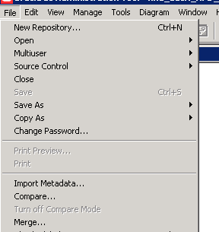

* Keep the ‘Full Repository Merge’ option and select the Original RPD (XXC_OBIA_ORIG.rpd) and the Modified RPD as the targent environment RPD (XXC_OBIA_MOD.rpd obtained from SVN) as well as their passwords. Provide Target environment password for merged RPD in order to avoid manual password change after the process

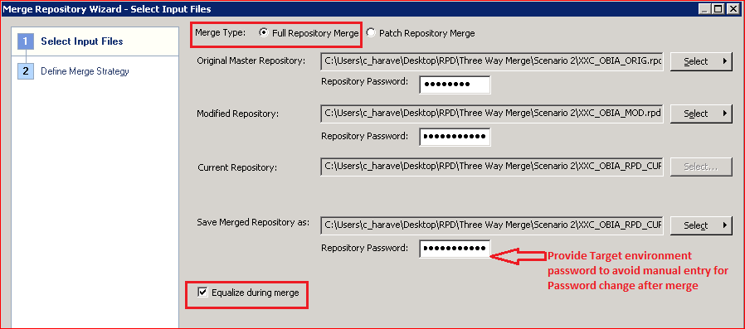

* Select the ‘Equalize during merge’ check box.

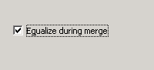

* Proceed to Merge

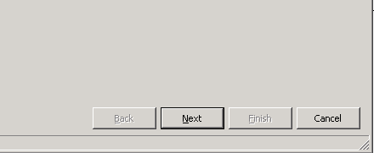

* In case of any errors in the equalization, this might throw an error message. **This error can be ignored for this release.** **Till this issue is completely resolved, please share the merge log and compare file generated in the following steps with the Dev team to ensure there is no impact.**

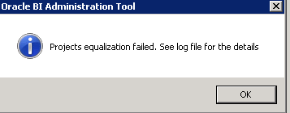

* **Resolve any conflicts by selecting either the current or the Modified RPD. In case of Release 2 , please select the ‘Current’ value under the Decision column as shown below.**





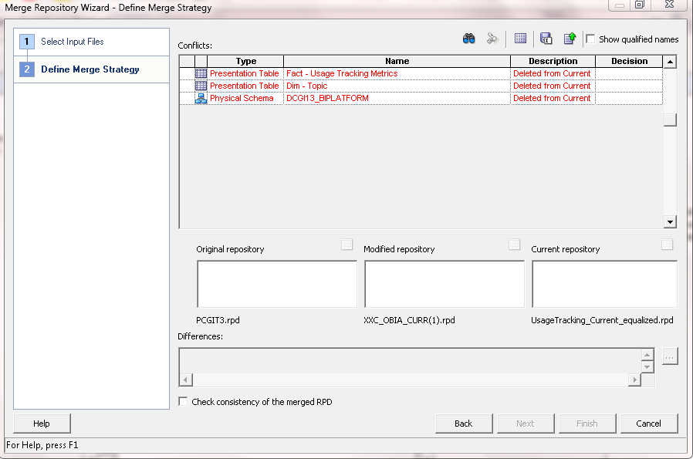

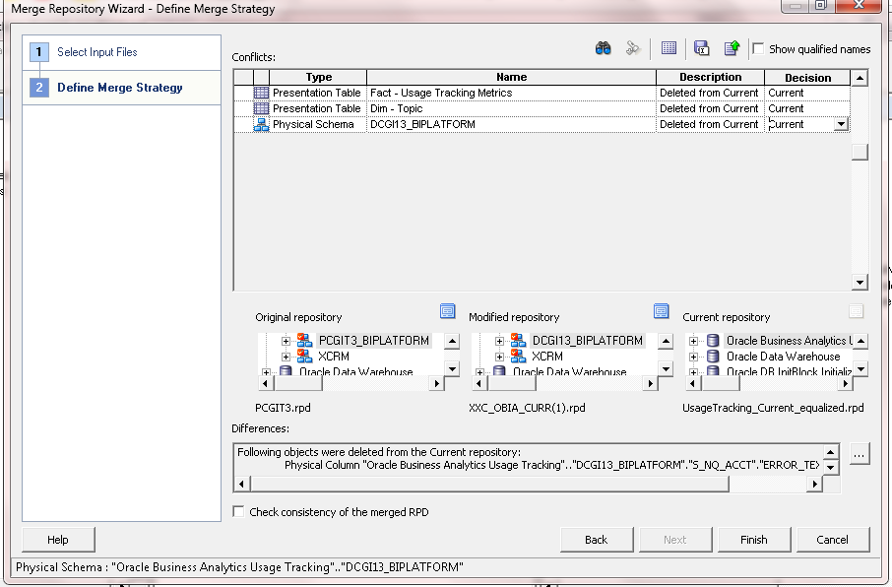

* Save the decision file once all the decision have been taken

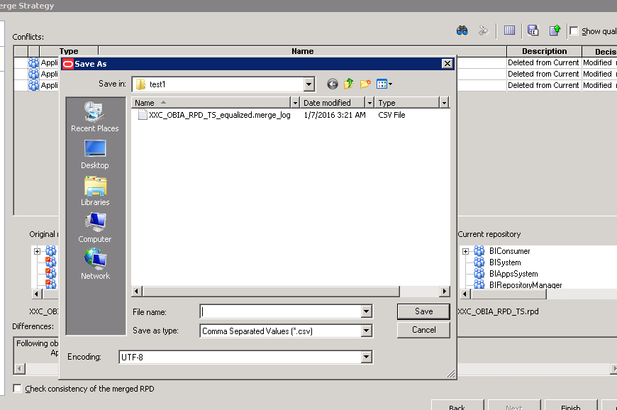

* Click on Finish to complete the merge process

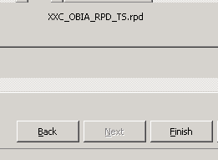

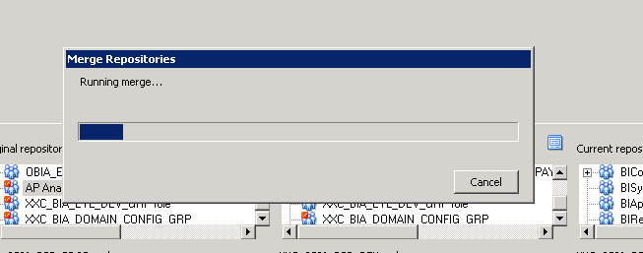

* Rename the resultant RPD to XXC_OBIA_RPD and check consistency**. Use this generated RPD for all further steps as well as upload to SVN post deployment in the target environment.**



**Verification & Auditing**

* **Do a compare with the original Target environment RPD to ensure only the relevant changes are made.Save the comparison results as a CSV file. This file could be compared with the Migration Tracker maintained to track all code changes to ensure that only the planned components are being migrated. This can be done during the migration window or post migration as per the constraints of deployment timelines.**
* **Attach the decision file, the merge file (File with the name similar to XXC_OBIA_RPD.merge_log that is automatically generated during the merge process in the folder where the RPD is saved) as well as the compare file (Generated in the previous step) to SVN. For example , please refer the files uploaded to SVN for release 1A.**

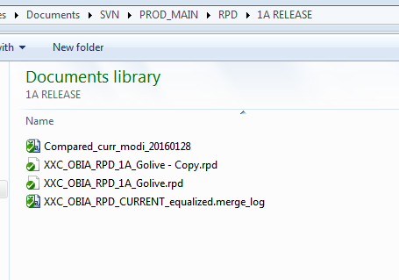

### Step 3 – Update RPD database connections

1. Your steps should be more specific than the examples shown.

* Open the RPD using Administration Tool in offline mode and provide the RPD password.
* **Update all the below connection according to the Target Environment**
* OLAP variables refer to the Datawarehouse while OLTP variables refer to EBS connection details.**Ensure that the following variables are pointing to the correct values as per the environment:**

|  |  |  |
| --- | --- | --- |
| **Variable** | **Comment** | **Example** |
| OLAP_DSN | Data warehouse DB Connection string | *'(DESCRIPTION=(ADDRESS_LIST=(ADDRESS=(PROTOCOL=TCP)(HOST=vmsodcgit007.ORACLEOUTSOURCING.COM)(PORT=31511)))(CONNECT_DATA=(SERVICE_NAME=TCGI13)))'* |
| OLAP_USER | Data warehouse Schema/User | *'TCGI13_DW'* |
| ORA_EBS_OLTP_DSN | EBS Database Connection string | *'(DESCRIPTION=(ADDRESS_LIST=(ADDRESS=(PROTOCOL=TCP)(HOST=vmohscgit025.oracleoutsourcing.com)(PORT=13910)))(CONNECT_DATA=(SERVICE_NAME=SCGI3I)))'* |
| ORA_EBS_OLTP_USER | EBS warehouse Schema/User | *‘APPS'* |
| CM_DSN | BI AppsConfiguration DB Connection String | *'(DESCRIPTION=(ADDRESS_LIST=(ADDRESS=(PROTOCOL=TCP)(HOST=vmsodcgit007.ORACLEOUTSOURCING.COM)(PORT=31511)))(CONNECT_DATA=(SERVICE_NAME=TCGI13)))'* |
| CM_USER | BI AppsConfiguration Schema/User | *' TCGI13_BIACOMP'* |
| CMTBO | BI AppsConfiguration Table Owner | *' TCGI13_BIACOMP'* |
| RT_DSN | Real Time DB Connection String | *(DESCRIPTION=(ADDRESS_LIST=(ADDRESS=(PROTOCOL=TCP)(HOST=vmsodcgit007.ORACLEOUTSOURCING.COM)(PORT=31511)))(CONNECT_DATA=(SERVICE_NAME=TCGI13)))'* |
| RT_USER | Real Time DB Connection Schema/User | *'xxc_bia_rtdw'* |
| OLAPTBO | Datawarehouse Table Owner | *' TCGI13_DW'* |

* Click Save

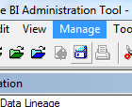

* Select ‘Yes’ when asked whether to check consistency.

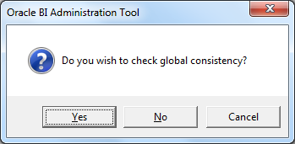

* Select ‘No when asked whether to mark as unavailable for queries.

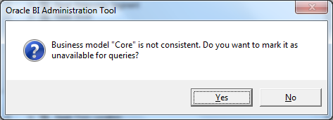

* Select only errors in the notification. Warnings can be ignored as of now.

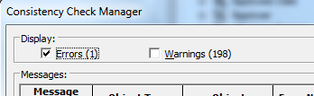

Note: The following error has been found to be caused due to a mismatch between the bit version of BI administration tool and the Oracle database client installed on the relevant machine where the changes are being made.

***[nQSError: 93001] Can not load library, oracore11.dll, due to, The specified module could not be found.***

***The specified module could not be found.***

***[nQSError: 15001] Could not load navigation space for subject area Core.***

* Any other error that might be notified in this consistency check needs to be communicated back to the Dev Team.

### Step 4 – Upload RPD to BI Server

* Open the Enterprise Manager URL Eg: https://<instance DSN>/em

Log in using a user with Global Admin privilege.

* Select core application from the list of objects

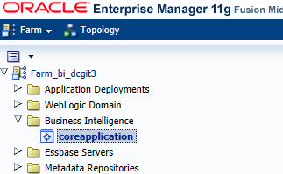

* Select the “Deployment” Tab. Click “Lock and Edit Configuration”

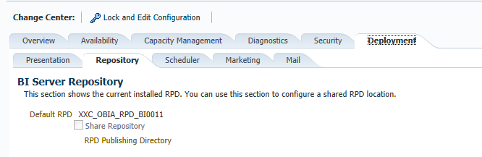

* Select the RPD from the local machine and provide the password (used earlier to open the RPD)

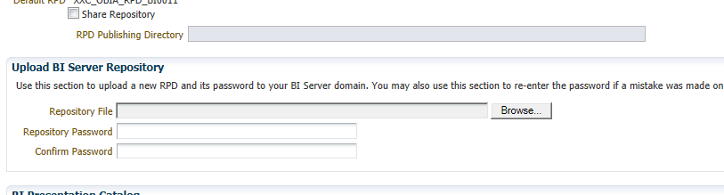

* Click “Apply” and then “Activate Changes”

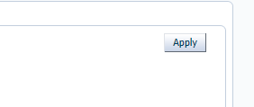

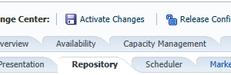

* Restart the services. Go to Availability -> Processes -> Restart All
* Open RPD in online mode and clear cache for all users.

### Step 5 – Upload RPD to SVN

* Upload RPD with all the connection string and Repository Variable changes to Target SVN location
* Do SVN Commit

## Verification Checklist

1. Include a subset of test steps that will confirm that the customization has been installed properly.

Verify that the deployment has been completed successfully by following these steps:

* Go to Diagnostics and ensure that there are no errors

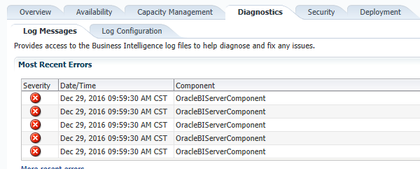

* Click on “More recent errors”

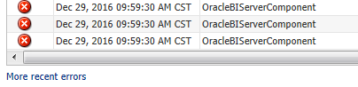

* Select Date range as Most Recent ->1 ->Hour (assuming the deployment was done within this duration).Select Message types as “Incident Error” and “Error”. Click search and sort by Time.

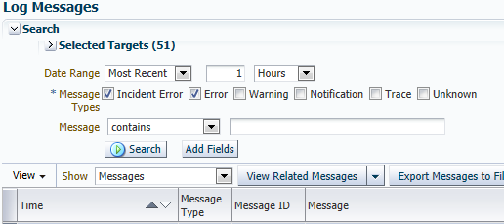

* Check specifically for errors related to Components “OracleBIServerComponent” and “OBIPS”

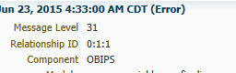



* The following are a list of possible errors encountered and the possible resolutions. We will be limiting the items to issues that could be introduced due to the deployment of the RPD.

|  |  |  |
| --- | --- | --- |
| Error | Type | Resolution |
| Top of Form  [nQSError: 17014] Could not connect to Oracle database. [nQSError: 17001] Oracle Error code: 12154, message: ORA-12154: TNS:could not resolve the connect identifier specified  at OCI call OCIServerAttach.Bottom of Form | Connectivity | Ensure the connection string is correct and the user credentials are working fine |
| An error occurred during execution of "send". Broken pipe [Socket:29] | Start Up/Inter component communication | A restart of all component fixes this issue most of the time |
| [nQSError: 13011] Query for Initialization Block 'PARAM_EFFECTIVE_DATE' has failed. | Connectivity | Go to variable manager (Menu>Manage>Variables), click on Initialization blocks (Session and Repository), right click on the respective Initialization block Query Related Objects ->Physical -> Connection Pool. Click Go To and ensure that the DB credentials entered are correct |

* Access the OBIEE URL and ensure Login without any issues. Do a high level sanity test to check for any errors in any reports. Any ORA error mean there are connectivity issues.

# Backout Plan

In case of any issues which is not fixed and is deemed a showstopper. Revert the RPD to the last version in Production SVN. Send a communication to Business, IT and any other stakeholders regarding the same.

# Open and Closed Issues

1. Add open issues that you identify while writing or reviewing this document to the open issues section. As you resolve issues, move them to the closed issues section and keep the issue ID the same. Include an explanation of the resolution.  
     
   When this work product is complete, any open issues should be transferred to the project- or process-level Issue Log (Manage focus area) and managed using a project level Issue Form (Manage focus area). In addition, the open items should remain in the open issues section of this work product, but flagged in the resolution column as being transferred.

## Open Issues

| ID | Issue | Resolution | Responsibility | Target Date | Impact Date |
| --- | --- | --- | --- | --- | --- |
|  |  |  |  |  |  |
|  |  |  |  |  |  |

## Closed Issues

| ID | Issue | Resolution | Responsibility | Target Date | Impact Date |
| --- | --- | --- | --- | --- | --- |
|  |  |  |  |  |  |
|  |  |  |  |  |  |